Welcome Parents and Coaches to the new online athletic registration for Holly Springs High School. The system that we will be using is called Dragon Fly. Both Parents and Coaches will need to sign up either on the app (you will need to download the app) or on a desktop/laptop.

Click HERE for sign up instructions.

Parents need to sign up in order to do the following:
- Add their child(ren) to their account
- Connect to Holly Springs High School
- Complete online paperwork to participate in sports at Holly Springs High School

Coaches need to sign up in order to do the following:
- See the students that have signed up for your team
- See the physical date for each student
- Complete the annual online Concussion Statement form

PARENTS:
If you have already signed up, added your child(ren), and connected to Holly Springs High School please go ahead and complete the online information.

Pay attention to the information below.
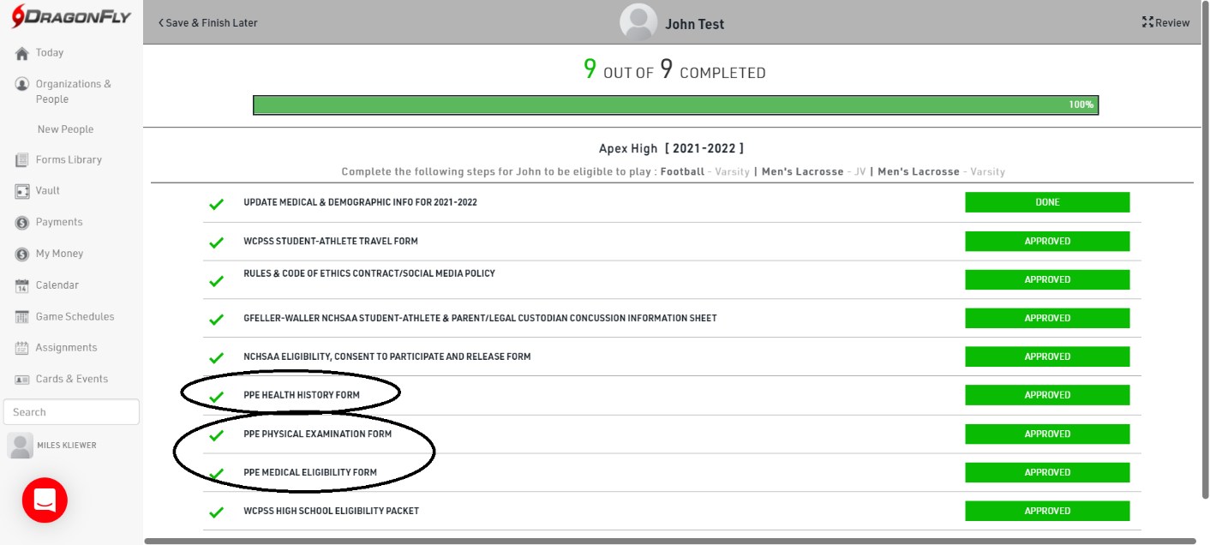
These forms will need to be printed out and taken to the Dr for completion. Upon completion, you will need to upload it into the registration.
This form can be filled out online. If you do complete it online, you will need to print it out to take to your physical exam appointment for the Dr to review. If you complete a hard copy, you will need to upload it into the registration.

Coaches:

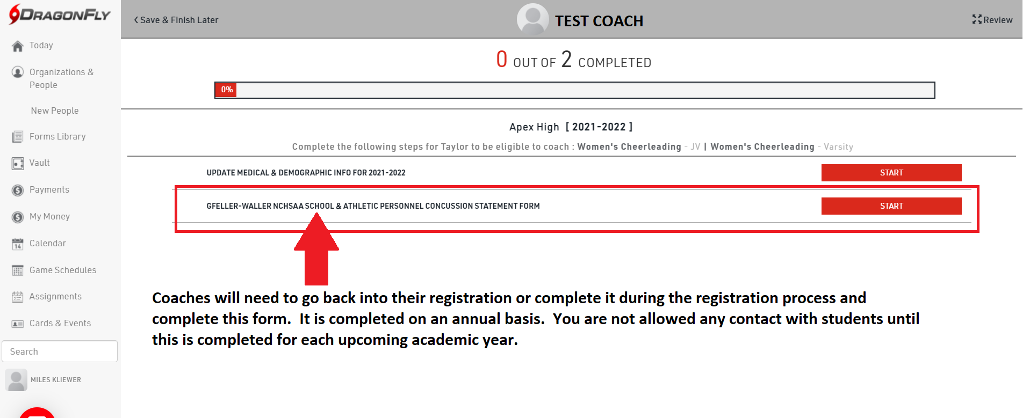

ALL:
If you want more instruction in these processes, please check out the following links.

- PARENTS click HERE.
- COACHES click HERE.

Parents, here are the documents that you will need for the registration process.
- Health History form- This form can be filled out online. If you do complete it online, you will need to print it out to take to your physical exam appointment for the Dr to review. If you complete a hard copy, you will need to upload it into the registration.
- Physical Exam form and Medical Eligibility form- These forms will need to be printed out and taken to the Dr for completion. Upon completion, you will need to upload them into the registration.

